**SECTION A (60 Marks)**

Answer only **three** questions from this section.

1. State what is meant by salt hydrolysis. (01 mark)
2. Calculate the pH of the solution prepared by mixing 80.0cm3 of 1M ammonia solution and an equal volume of 1M hydrochloric acid. [Kb of ammonia = 1.75 x 10-5mol/dm3 at 25ᵒC and Kw = 1.0 x 10-14mol2/dm6 at 25ᵒC] (05 marks)
3. Explain what happens when the resultant solution in (b) above is treated with the following substances.
4. Sodium thiosulphate. (02 marks)
5. Calcium powder. (01½ marks)
6. The table below shows the pH of a solution obtained when different volumes of hydrochloric acid were added to 25.0cm3of 0.1M ammonia solution.

|  |  |  |  |  |  |  |  |  |
| --- | --- | --- | --- | --- | --- | --- | --- | --- |
| Volume of HCl (cm3) | 0 | 10.0 | 15.0 | 16.5 | 17.0 | 20.0 | 25.0 | 30.0 |
| pH of solution | 9.90 | 9.08 | 8.30 | 6.70 | 2.97 | 1.96 | 1.60 | 1.40 |

1. Plot a graph of pH against volume of hydrochloric acid. (03 marks)
2. Explain the shape of the graph you have drawn. (03½ marks)
3. Determine from the graph:
4. Concentration of hydrochloric acid in mol/dm3. (03 marks)
5. Base ionization constant, Kb for ammonia. (02½ marks)
6. (i).Write the electronic configuration of a chromium atom.(0½ mark)

(ii).State the common oxidation states of chromium in its compounds

(01 mark)

1. Describe the reaction of chromium with:
2. Aqueous sodium hydroxide solution. (02 marks)
3. Sulphuric acid. (04 marks)
4. Dilute sodium hydroxide solution was added to chromium (III) chloride solution drop wise until in excess, followed by a few drops of hydrogen peroxide and the mixture warmed.
5. State what was observed. (02 marks)
6. Explain your observation in (c) (i) above. (06½ marks)
7. Potassium chromium (III) sulphate was dissolved in water and few drops of concentrated potassium hydrogen carbonate were added. Explain what was observed. (04 marks)
8. Describe the term partition coefficient. (01 mark)

(b).Describe an experiment that can be carried out to determine the partition coefficient, Kb of ethanedioic acid [oxalic acid] between ethoxyethane and water. (06 marks)

1. 50.0cm3 of an aqueous solution containing 6g of T was in equilibrium with 100.0cm3 of ethoxyethane containing 108g of T. Calculate the partition coefficient, KD. (02 marks)
2. Explain the shape of the graph. (02 marks)
3. Using your answer in (c) above, Calculate the mass of T extracted by shaking 100.0cm3 of an aqueous solution containing 30g of T with:
4. 100.0cm3 of ethoxyethane. (02 marks)
5. Two portions of 50.0cm3 of ethoxyethane. (03 marks)
6. 50.0cm3 of 0.8M aqueous ammonia solution was added to 50.0cm3 of trichloromethane in a flask. To the resultant mixture was added 0.1M nickel (II) sulphate solution. The mixture was shaken and allowed to stand at constant temperature. Some ammonia reacted with nickel (II) ions to form a complex, Ni(NH3)n2+ 25.0cm3 of the organic layer required 20.0cm3 of 0.01M hydrochloric acid for complete reaction. Determine the value of n in the complex formed.[KD of ammonia between trichloromethane and water = 0.04 at 25ᵒC]
7. The molecular structure of compound, Z is H2C=CHCOCH3.
8. Write the mechanism for the reaction that would take place when compound, Z reacts with the following reagents.
9. Bromine water. (03 marks)
10. 4-nitrophenyl hydrazine solution. (04 marks)
11. Saturated sodium hydrogen sulphite. (03 marks)
12. Write equations to show how the following conversions can be carried out. Indicate the conditions and reagent for the reaction.
13. Phenylethanone to phenylethanal. (04 marks)
14. Ethene to methylbenzene. (03 marks)
15. Benzene to methylbenzoate. (03 marks)

**SECTION B (40 Marks)**

Answer only **two** questions from this section.

1. Describe:
2. The industrial preparation of sulphuric acid. (01 mark)
3. State the uses of sulphuric acid. (01 mark)
4. Describe the reactions of sulphuric acid with:
5. Iron. (04 marks)
6. Copper. (02 marks)
7. Write an equation to show how sulphuric acid is used to prepare a super phosphate fertilizer. (01 mark)
8. Concentrated sulphuric acid is 98% and has a density of 1.84g/cm3. Calculate the volume of the required to prepare 1 litre of 2M dilute acid solution. (04 marks)
9. A compound, W contains 14.8% carbon, 1.8% hydrogen, 19.7% oxygen and the rest being lead.
10. Determine the molecular formula of compound, W. [ Molar Mass, Mr of compound, W = 325g] (03 marks)
11. When compound, W was heated with concentrated sulphuric acid, Solid, A and a colourless sharp-smelling liquid, B was formed.
12. Identify solid, A and liquid, B. (01 mark)
13. Write equation for the reaction leading to formation of solid, A and liquid, B. (01 mark)
14. Using equations only, show how:
15. Compound, W can be converted to 1,2-dichloropropane. (03½ marks)
16. Liquid, B can be prepared from methanol. (04 marks)
17. State what would be observed and write equation (s) for the reaction (s) that would take place when an aqueous solution of compound, W is reacted with following:
18. Potassium chromate (IV) solution. (01½ marks)
19. Concentrated hydrochloric acid dropwise until in excess. (02 marks)
20. Write an equation and outline the mechanism for the reaction between liquid, B and ethanol in the presence of concentrated sulpuric acid. (04 marks)
21. (a).Define the following terms: (@01 mark)
22. Common ion effect.
23. Solubility product.
24. Strontium hydroxide is sparingly soluble in water according to the following equation:
25. Write expression for the solubility product, Ksp for strontium hydroxide. (01 mark)
26. Describe an experiment which can be carried out to determine the solubility product of strontium hydroxide. (08 marks)
27. The solubility of strontium hydroxide is 5.24g/dm3 of water at 293K. Calculate the:
28. Solubility product of strontium hydroxide at 20ᵒC and give its S.1 units. (03½ marks)
29. Volume of 0.02M potassium chromate (VI) solution that must must be added to 1dm3 of a saturated solution of strontium hydroxide to precipitate strontium chromate (VI). [Ksp 4 SrCrO4 = 3.6 x 10-2 mol2/dm6 at 293K] (03½ marks)
30. Potassium hydroxide solution was added to a saturated solution of strontium hydroxide. Explain what happened to the solubility of strontium hydroxide. (02 marks)
31. Explain the following observations.
32. A solution of iodine and aqueous sodium hydroxide solution gives a pale yellow precipitate with ethanol but gives no observable change with methanol. (05 marks)
33. The molar ionic conductivity of sodium and rubidium ions are 50.0 & 78.3Ω-1cm2/mol respectively. (05 marks)
34. When aqueous sodium hydrogen carbonate solution is added to zinc chloride solution, a white precipitate is formed with bubbles of a colourless gas. Calcium chloride solution gives no observable change when reacted with the same reagent. (05 marks)
35. An aqueous solution of ammonium sulphate turns moist blue litmus paper red while an aqueous solution of potassium sulphite turns moist red litmus blue. (04 marks)
36. When lead (IV) oxide is added to manganese (II) chloride followed by concentrated nitric acid, a purple solution is formed. (02 marks)

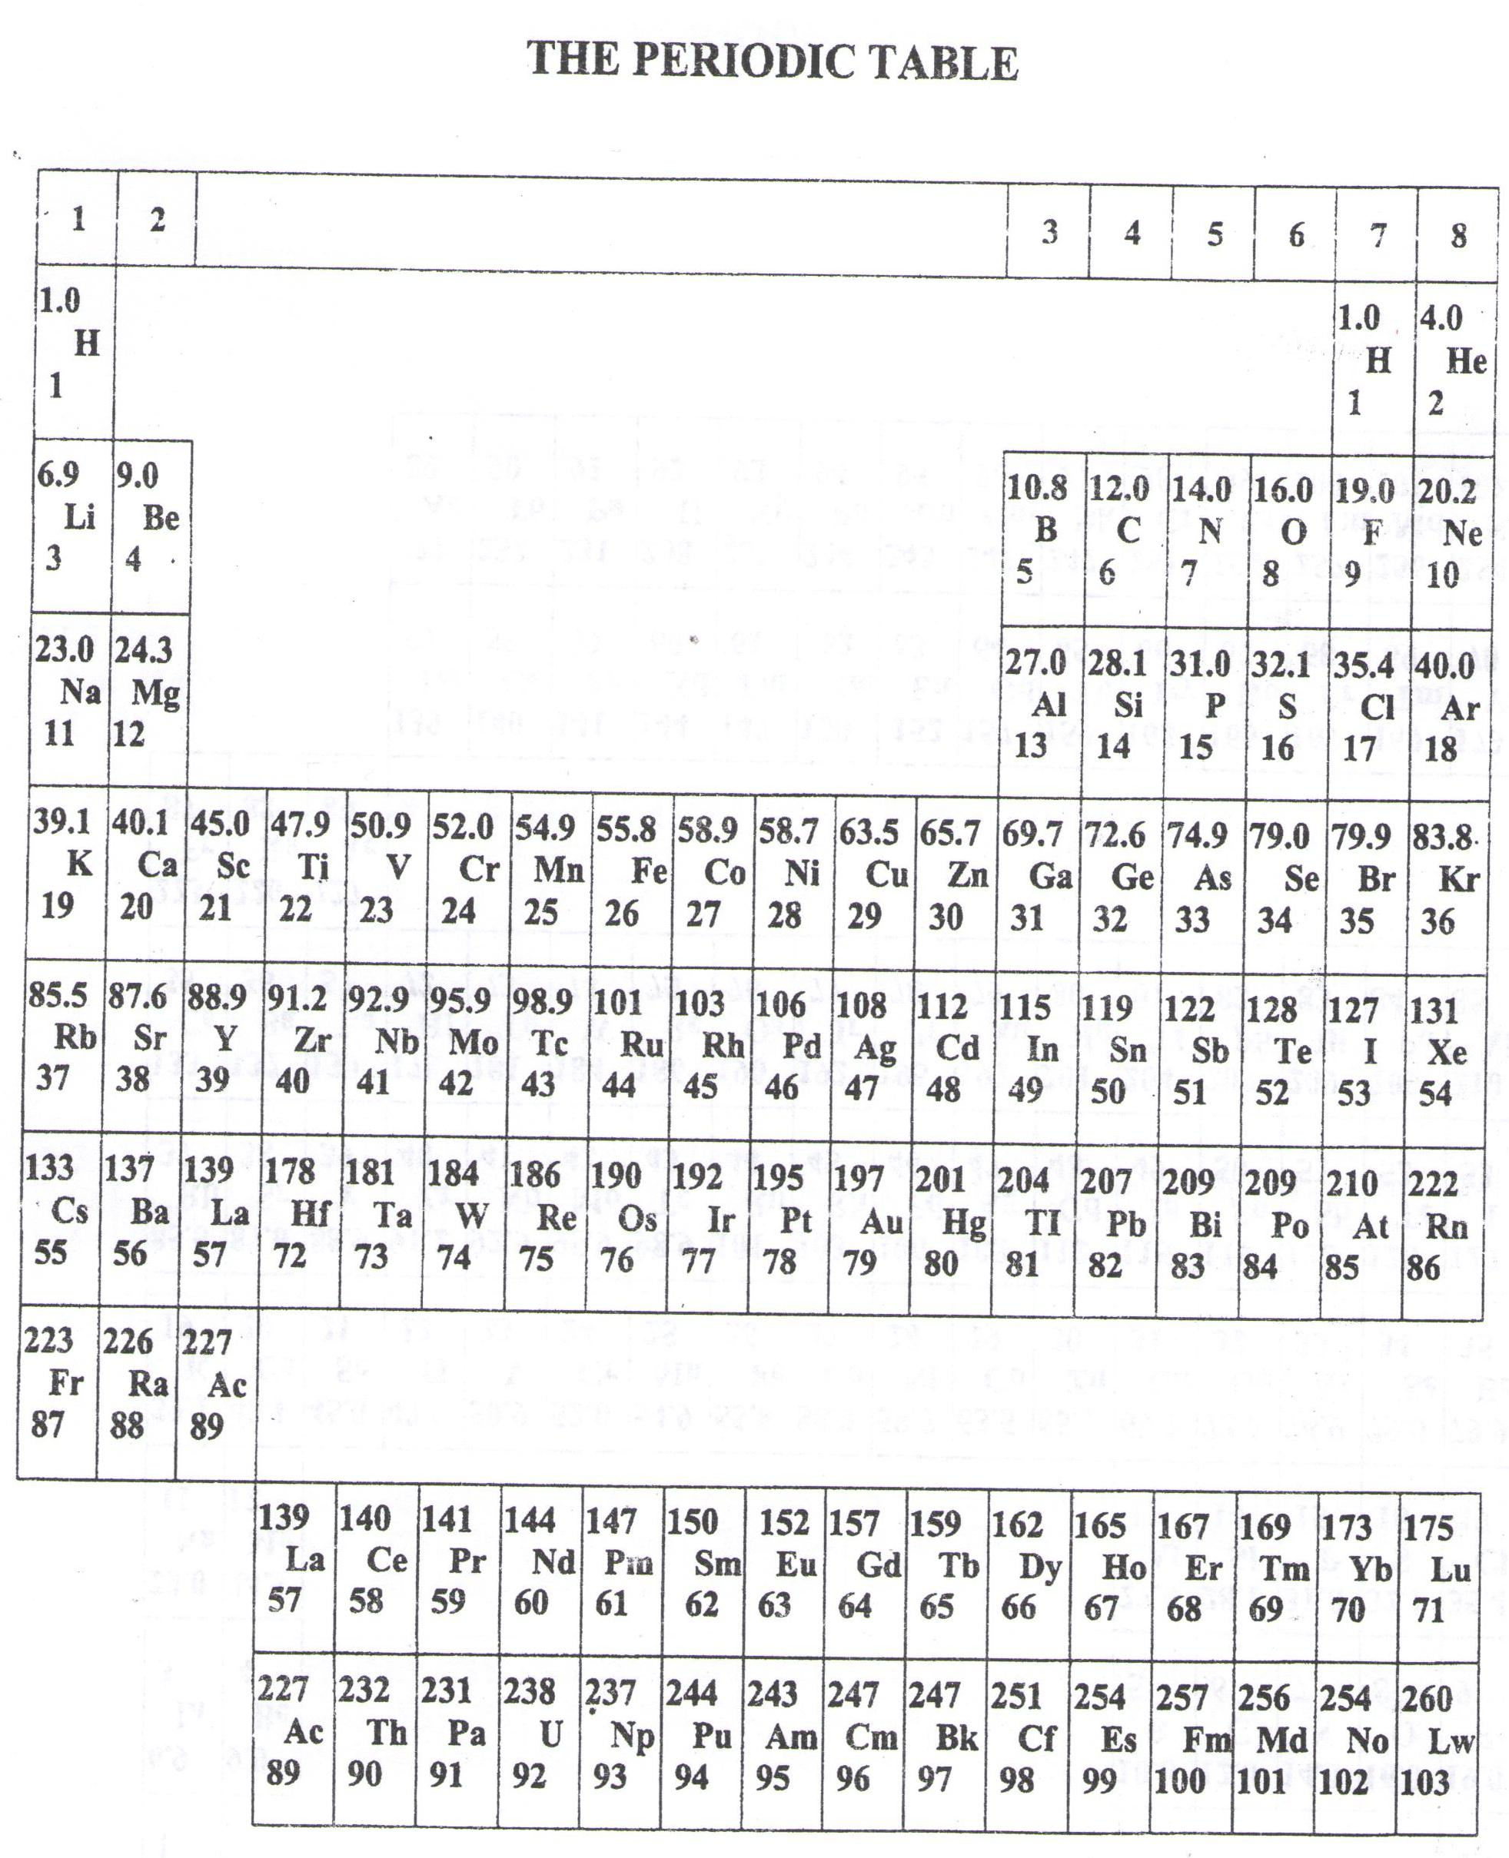

* ===END===

WELCOME TO SENIOR SIX, YEAR 2023

This is the last page of the printed paper, Page 06